[Group 72] LearnLoop - A Stateful Agentic Platform for Adaptive Learning

Group Members
Name | Student ID | Email
Fong Chi Ching | 3035299466 | u3529946@connect.hku.hk
Ching Nok Yee | 3035283572 | u3528357@connect.hku.hk
Lai Hok Lam Justin | 3036657081 | u3665708@connect.hku.hk
Zhou Yuxin | 3036791693 | u3679169@connect.hku.hk

2. Project Objective
This project aims to build LearnLoop, an agentic learning platform that turns a student's uploaded course materials into an adaptive, persistent learning journey. Given a set of documents and a learner-defined goal, LearnLoop decides what the learner should do next and whether they have understood it, revising the plan as evidence accumulates across sessions. The deliverable is a working end-to-end system, not a model or a single prompt.
We pursue three objectives:
- Decide the next best action. A source-grounded agent–environment loop, informed by ReAct [1], proposes an educational action, the runtime validates and executes it, and the observation informs the next decision.
- Ground decisions in course content. LearnLoop derives learning items and prerequisites from the uploaded materials, scaling depth to each document's length and structure, and maintains topic and learner state through reusable mission templates.
- Verify and track progress. Actions are validated before execution, and learner state updates only on rubric-meeting evidence, so the system distinguishes lasting misunderstandings from temporary mistakes and resumes interrupted sessions.
To evaluate, we will use 40 held-out multi-step scenarios, each run three times per system. We compare LearnLoop against a fixed-sequence tutor and a tutor without cross-session memory, measuring adaptive decision quality, assessment quality, state reliability, workflow robustness, and latency and cost (Section 5).

3. Motivation and Challenges
Students often receive course outlines, slides, and readings but are unsure where to start, which ideas matter most, or what they need to understand first. They may review familiar topics while overlooking gaps in their knowledge. Asking a chatbot to explain a topic is possible, but the quality depends heavily on how the question is phrased. It is also hard to keep track of their own progress.
LearnLoop addresses this by organizing uploaded materials into a learning path, checking what students understand, and offering practice or explanations where needed. By remembering earlier attempts, it revisits difficult topics and adjusts the plan over time. Research on intelligent tutoring systems supports this approach [2]. We will evaluate whether LearnLoop selects useful activities and helps students navigate their materials more confidently.
The main challenges are recognizing a lasting misunderstanding rather than a temporary mistake, finding reliable support in the uploaded materials, and keeping an accurate record of progress. We will check assessment evidence before updating the learner's state, allow the system to express uncertainty, and limit repeated attempts when tools fail. Missions and rewards will support the learning tasks, while progress will depend on demonstrated understanding. We will assess learning and motivation separately, as suggested by research on gamification [3].

4. Potential Solutions

4.1 Knowledge Graph Based Multi Agent Architecture
LearnLoop will use three specialized agents within a shared agentic workflow: an Expert Agent, a Tutoring Agent, and an Assessing Agent. Together, they will follow a continuous construct, teach, assess, and adapt cycle. Each agent will have distinct responsibilities and tools, while a shared runtime will manage state, validate outputs, and record execution traces. Figure 4.1 in Appendix B shows the architecture and validated feedback loop.
The Expert Agent will process COMP7608B course materials and construct a source-grounded knowledge graph. Each node will represent a course concept, while edges will represent prerequisite, dependency, or related-topic relationships. The agent will also generate explanations, examples, questions, hints, reference answers, and assessment rubrics at three difficulty levels: basic (recall and direct conceptual understanding), intermediate (application, comparison, and explanation), and advanced (analysis and multi-concept reasoning). Supporting course passages will be retrieved using retrieval-augmented generation [4].
When appropriate, the Expert Agent may retrieve recent developments for optional enrichment. External information will be clearly separated from the core course knowledge used in formal teaching and assessment. All generated concepts, relationships, and learning resources will retain references to their supporting course passages or external sources.
The Tutoring Agent will select the next concept, activity, and difficulty according to the course knowledge graph and the learner’s current state. Candidate concepts will first be filtered according to prerequisite readiness and then ranked using learner need, assessment uncertainty, review urgency, and recent performance. The agent may introduce an unassessed concept, provide further practice, adjust question difficulty, revisit a prerequisite, reassess a review-due concept, or advance the learner to a related concept.
The Assessing Agent will evaluate learner responses using rubric coverage, question difficulty, response time, hint usage, previous attempts, and contradictory evidence. Correctness and rubric coverage will provide the primary evidence, while the remaining signals will adjust the strength of that evidence. The agent will record misconceptions and propose learner-state updates, but a deterministic runtime will validate each update before committing it.

4.2 Difficulty Aware Learner Model
LearnLoop will represent each learner as a personalized overlay on the course knowledge graph. The underlying graph will be shared across learners, while each learner will have separate concept-level assessment evidence and progress states. This persistent evidence model is inspired by knowledge tracing [5]; the prototype will use explicit transition rules.
Each concept will retain one overall state: unassessed (insufficient evidence), developing (partial understanding or supported success), demonstrated (sufficient independent evidence at the required difficulty), or review_due (previously demonstrated understanding needs reassessment).
Because performance may differ by question difficulty, the learner model will also maintain separate evidence for basic, intermediate, and advanced activities. A learner may therefore be demonstrated at the basic level, developing at the intermediate level, and unassessed at the advanced level. The overall concept state will be determined relative to the target difficulty defined for that concept.
The learner model will store assessment outcomes by difficulty, independent and hint-assisted attempts, response-time observations, identified misconceptions, contradictory evidence, and the last assessment date and review schedule.
State changes will require validated evidence rather than a single response or unsupported model judgement. For the prototype, demonstrated status will require repeated rubric-meeting responses at the target difficulty without hints or unresolved contradictory evidence. Later errors will not erase previous evidence, but may trigger diagnosis or move the concept to review_due or developing.

4.3 Autonomous Learning Loop and Runtime Control
LearnLoop will follow a closed loop connecting knowledge construction, personalized tutoring, learner assessment, and state adaptation. After the Expert Agent prepares the knowledge graph and resources, the Tutoring Agent will select a concept, activity, and difficulty using the graph and learner state. Following ReAct [1], tool outcomes and assessment observations will inform each subsequent decision.
After an activity, the Assessing Agent will propose a concept-state update using the evidence described above. The runtime will validate source support, prerequisite relationships, and the permitted transition before committing it. The updated state will become a new observation for the Tutoring Agent. Retained assessment feedback and summaries will support adaptation across sessions, drawing on feedback-based agent memory [6].
The loop will respond to rapid progress, persistent misconceptions, hint dependence, difficulty-specific weaknesses, conflicting evidence, and knowledge decay. It may adjust difficulty, provide targeted remediation, revisit prerequisites, schedule review, or advance. Typed tool contracts, version checks, unique operation IDs, and durable checkpoints will support validated execution and session resumption. Bounded retries and explicit insufficient-evidence outcomes will control failures; the runtime will pause for learner input or stop at execution limits.
Structured traces will record decisions, tool calls, evidence, proposed and committed updates, latency, token consumption, and cost for multi-step performance and trajectory evaluation [7]. Appendix A provides tool contracts and acceptance cases.

5 Experimental Dataset Description and Evaluation Plan

5.1 Course Dataset and Learning Resources
The initial dataset will consist of selected COMP7608B course materials. To maintain a feasible scope, the prototype will focus on one coherent course unit containing approximately 10 to 20 concepts and their relationships. The Expert Agent will use these materials to generate a source-grounded knowledge graph, concept descriptions and learning objectives, explanations and worked examples, questions at three difficulty levels, progressive hints, reference answers, and assessment rubrics. Generated nodes, edges, questions, and rubrics will retain links to the supporting course passages. The group will manually review a sample of the generated resources for conceptual correctness, source grounding, prerequisite accuracy, and appropriate difficulty. Test questions used for final evaluation will be excluded from the agents’ retrieval and teaching resources.

5.2 Prompt Configurations
Three prompt variants per agent will form a 3×3×3 factorial design with 27 configurations. Expert prompts will vary structural guidance, grounding, and verification; Tutoring prompts will use state-based, graph-aware, or utility-based selection; Assessing prompts will use correctness-focused, evidence-weighted, or conservative assessment. Model versions, tools, schemas, course information, and activity budgets will remain fixed to isolate prompting effects.

5.3 Controlled Learner Simulation
Each configuration will interact with the same controlled LLM-based pseudo-students. Hidden profiles will specify initial knowledge, difficulty-specific ability, misconceptions, hint dependence, response characteristics, and memory of prior teaching. Profiles will cover novice, intermediate, misconception-prone, and hint-dependent learners. Simulator states will remain separate from LearnLoop’s estimates, enabling learner-state accuracy checks. Each configuration will be run repeatedly with the same initial states, activity limits, and stopping conditions to reduce stochastic variation.

5.4 Evaluation Measures
We will evaluate four dimensions using the measures below.
Measure | Definition or assessment
Learning quality | Performance on an unseen post-test, concepts mastered, learning gain per activity, and activities required to reach the target performance
Learner-state accuracy | Agreement between LearnLoop’s estimated states and the pseudo-student’s hidden states, including macro F1, difficulty estimation, misconception detection, and false-demonstration rate
Trajectory quality | Appropriateness of concept selection, prerequisite consistency, difficulty suitability, evidence use, state-update validity, redundancy, and recovery from uncertainty
Operational performance | Input and output tokens, monetary cost, cost per mastered concept, end-to-end latency, and median and p95 latency by agent
A fixed, unseen post-test will be administered after each learning episode. The post-test will contain questions at multiple difficulty levels and will be evaluated independently of the experimental Assessing Agent. This prevents an overly lenient assessor from appearing successful by assigning demonstrated prematurely. Structured traces will record the learner evidence available to each agent, candidate and selected actions, tool calls, concept and difficulty choices, proposed and committed state changes, errors, retries, token consumption, latency, and cost. Trajectories will be reviewed using a common rubric, while deterministic checks will identify prerequisite violations, invalid transitions, repeated actions, and unsupported mastery updates.

5.5 Controls and Analysis
All configurations will share the knowledge graph, resources, learner profiles, model settings, activity pools, turn limits, post-test criteria, tool permissions, and runtime budgets. Analysis will examine individual agent-prompt effects and interactions, comparing quality, learner-state accuracy, trajectory quality, latency, and cost. We will identify configurations on the quality-efficiency frontier. If repeated full-length evaluation is too expensive, all 27 configurations will undergo short screening, followed by repeated full evaluation of the strongest non-dominated configurations.

Appendix A Agent Responsibilities and Runtime Contracts
These planned interfaces define how the three agents use the shared course knowledge base and persistent learner model. Agents propose actions and evidence; the runtime authorizes tools and commits validated writes. All records are scoped to the authorized course and learner.

A1 Agent Responsibilities
Agent | Inputs and responsibilities | Output and handoff
Expert | Course documents and source passages; extract concepts and prerequisites, then generate resources at three difficulty levels. | Proposed graph and resources with passage references; runtime validates before publication.
Tutoring | Validated graph, learner evidence, goal and review schedule; filter by prerequisites and select concept, activity and difficulty. | Activity proposal with objective, evidence and rationale; runtime assigns the activity to the learner.
Assessing | Learner response, activity rubric, source passages, hint usage and previous evidence; assess coverage and uncertainty. | Assessment evidence, misconceptions and candidate state update; runtime validates and commits.

A2 Shared Tool Contracts
Every tool returns a status, evidence or result identifiers, and a structured error when unsuccessful. Write operations use an operation_id and, where applicable, an expected_version; retries return the original committed result rather than duplicating it.
Tool and caller | Input contract | Result and runtime checks
retrieve_evidence  All agents | course_id, concept_id, query | Source passages and page IDs; enforce course scope and retrieval limits. Empty results preserve an evidence gap.
publish_resources  Expert | operation_id, course_id, graph, resources, source_ids | Versioned graph and resource IDs; check source references, concept IDs, prerequisite cycles, and rubric/difficulty fields.
load_learner_state  Tutoring or Assessing | learner_id, concept_ids | Selected evidence records and version; enforce learner ownership before loading context.
assign_activity  Tutoring | operation_id, learner_id, concept_id, difficulty, activity_type, evidence_ids | Persisted activity ID; validate prerequisite readiness, objective, resource and difficulty. Duplicate IDs reuse the prior result.
assess_response  Assessing | activity_id, response, hint_used, prior_evidence_ids | Rubric coverage, correctness, misconception candidates and uncertainty; validate activity, rubric and source references.
record_assessment  Assessing via runtime | operation_id, learner_id, expected_version, assessment_id, candidate_update | Committed evidence and permitted concept state; reject stale versions and unsupported demonstration.
revise_plan  Tutoring | operation_id, learner_id, expected_version, activity_ids, review_dates | New plan version; check ownership, prerequisites and referenced activities before transactional write.

A3 Learner State and Persistence
Each concept record will retain the target difficulty, overall state, evidence at basic/intermediate/advanced levels, independent and hinted attempts, rubric results, misconceptions, contradictions, timestamps and review dates. Assessment evidence will be appended rather than overwritten. The runtime will derive overall status against the target difficulty.
State | Entry or transition rule
unassessed | No sufficient assessment evidence is available.
developing | Partial understanding or hint-assisted success is observed; further independent evidence is needed.
demonstrated | Repeated independent responses meet the rubric at the target difficulty, with no unresolved contradictions.
review_due | A demonstrated concept reaches its review date or new evidence calls for reassessment; earlier evidence remains available.
Pending activities, committed evidence, plan versions and operation results will be saved at durable checkpoints. Timeouts, restarts and retry exhaustion will leave a resumable status. Response time and hint usage may qualify evidence strength but will not independently establish demonstrated understanding.

Appendix B Current System Architecture
Figure 4.1 shows the course preparation stage and the adaptive learning loop. The Expert Agent supplies a shared course knowledge base. The Tutoring Agent uses course evidence and current learner state to select an activity. The Assessing Agent evaluates the learner’s response against the rubric and course sources. Only a validated runtime commit changes the persistent learner model, which informs the next tutoring decision.
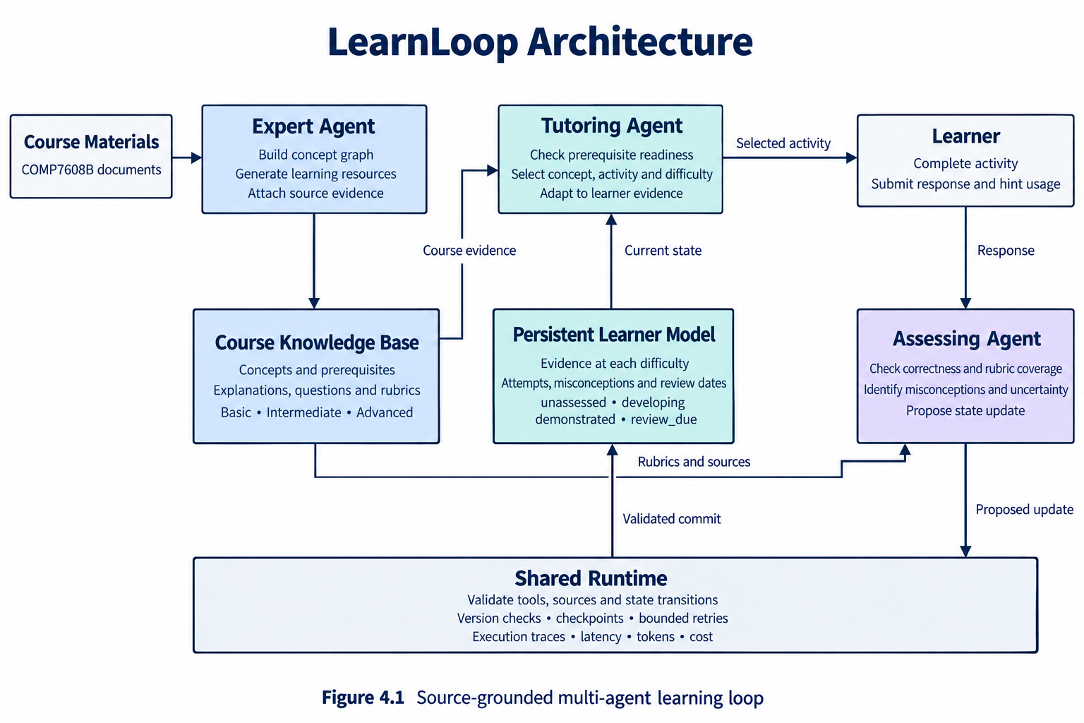
The shared runtime also validates tool actions, checks record versions, maintains checkpoints, bounds retries, and logs latency, token use and cost. Missions and rewards remain supporting interface features; they do not form a fourth agent or determine learner-state transitions.

Appendix C Verification and Evaluation Details

C1 Planned Acceptance Cases
These cases will be implemented as executable checks of proposed versus committed actions and durable state. They are planned tests, not reported results.
Case | Expected behavior
Unsupported course resource | A concept, relationship or rubric without valid source evidence is rejected or flagged for review before use.
Prerequisite violation | An activity requiring an unmet prerequisite is blocked; the Tutoring Agent receives the reason and selects remediation.
Hint dependent success | A correct hinted answer is recorded but cannot independently support demonstrated status.
Difficulty mismatch | Basic-level success does not demonstrate an intermediate or advanced target; evidence remains separated by difficulty.
Contradictory evidence | A later error preserves earlier evidence and triggers diagnosis or a permitted change to developing/review_due.
Missing or uncertain evidence | Empty retrieval or inconclusive grading produces an explicit uncertainty outcome; unsupported state advancement is blocked.
Resume and stale writes | A pending activity resumes from its checkpoint. A write using an outdated version is rejected and current state is reloaded.
Duplicate operation | A retry after a committed write returns its original result without a second activity or assessment entry.
Budget exhaustion | The runtime stops at configured retry, turn or token limits and retains a progress record.

C2 Evaluation Protocol
The evaluation has two complementary parts. The 27 prompt configurations test how Expert, Tutoring and Assessing prompts affect learning and operational quality. The 40 held-out multi-step scenarios described in Section 2 compare the selected LearnLoop configuration with the fixed-sequence and memory-free baselines, with three runs per system. Scenario prompts and final test questions will be withheld from teaching and retrieval resources.
Pseudo-student hidden profiles and simulator states will remain separate from the learner model. Identical profiles, initial states, resources, activity limits and generation settings will be used for paired comparisons. The unseen post-test will be scored independently of the experimental Assessing Agent. State accuracy will include macro F1 and the false-demonstration rate; trace review will assess prerequisite consistency, evidence use, redundancy and recovery. Operational logs will support median/p95 latency, token consumption, total cost and cost per mastered concept.

C3 Limitations and Interpretation
A small reviewed course unit supports controlled evaluation but does not establish autonomous curriculum discovery or generalization across subjects. LLM-based pseudo-students may behave differently from real learners; their post-test gains therefore measure performance within the simulation rather than human learning outcomes. Source-grounded generation and rubric-based assessment can still make errors. Uncertain grading, persistent misconceptions, invalid graph relationships and recovery failures will be reported explicitly. Gamification benefits remain exploratory and will not be inferred from state accuracy or simulator performance.

References
[1] Yao, S., Zhao, J., Yu, D., Du, N., Shafran, I., Narasimhan, K., and Cao, Y. (2023). ReAct: Synergizing Reasoning and Acting in Language Models. International Conference on Learning Representations (ICLR). Source
[2] Ma, W., Adesope, O. O., Nesbit, J. C., and Liu, Q. (2014). Intelligent tutoring systems and learning outcomes: A meta‑analysis. Journal of Educational Psychology, 106(4), 901–918. Source
[3] Sailer, M., and Homner, L. (2020). The Gamification of Learning: A Meta‑analysis. Educational Psychology Review, 32, 77–112. Source
[4] Lewis, P., et al. (2020). Retrieval‑Augmented Generation for Knowledge‑Intensive NLP Tasks. Advances in Neural Information Processing Systems, 33, 9459–9474. Source
[5] Corbett, A. T., and Anderson, J. R. (1994). Knowledge tracing: Modeling the acquisition of procedural knowledge. User Modeling and User‑Adapted Interaction, 4, 253–278. Source
[6] Shinn, N., Cassano, F., Gopinath, A., Narasimhan, K., and Yao, S. (2023). Reflexion: Language Agents with Verbal Reinforcement Learning. Advances in Neural Information Processing Systems, 36. Source
[7] Liu, X., et al. (2024). AgentBench: Evaluating LLMs as Agents. International Conference on Learning Representations (ICLR). Source

